THRESHOLD AND OPERATING VOLTAGE OPTIMIZATION (TOVO)

Introduction:
This manual is intended for use with the Quark Net/ Walta/ CROP Cosmic Ray Detector and 5000 series Data Acquisition Board (DAQ board). Before doing any type of performance study using the cosmic ray detector an optimum operating and threshold voltage must be selected for each detector. The materials and procedures needed to determine the optimum operating and threshold voltage for each detector is included.

The optimum threshold voltage is selected to give the best signal to noise ratio. Signals coming from the photomultiplier tube need to be larger than the threshold voltage in order to be recognized as a count. Setting the threshold voltage too low allows all signals regardless of their size to be counted including background noise. Setting the threshold too high will only allow the most energetic cosmic rays to be detected and the less energetic cosmic rays will be missed. The best threshold voltage is obtained by selecting the voltage at the “elbow” of a count rate versus threshold voltage graph. The “elbow” of the graph occurs where there is a decrease in the slope of the graph. (See Appendix A) When the threshold voltage is low the rate of change in count rates is high so the slope of the graph is steep or even exponential. As the threshold voltage is increased above the voltage of most of the noise pulses the rate of change in count rate decreases, so the slope of the graph is not as steep.

The optimum operating voltage is also selected to give the best signal to noise ratio. If the operating voltage is too low only noise will be detected. If the operating voltage is too high noise and signals will trigger the detector with the same response. The best voltage is obtained from the middle of the directly varying region (not the flat region) of a count rate versus operating voltage graph. (See Appendix B)

Materials:
Cosmic Ray Detector
5000 DAQ board
Voltmeter
Computer with Excel and Hex to Decimal conversion enabled (found under Tools, Add ins, Analysis tool pack)
HyperTerminal
Small Screwdriver
Stopwatch

Procedure Part A: Optimizing the Threshold Voltage

1. Set the operating voltage for each detector to 1.0 V (The optimum operating voltage will be determined in procedure part B).

2. Use a screwdriver to adjust the potentiometer on the DAQ board to set the threshold voltage for each detector at 0.3 V. Check settings using a voltmeter.

3. Disconnect the voltage and signal cables for detectors 1, 2, and 3 to find the threshold voltage for detector 0.

4. Depress the reset button on the DAQ board at the same time a stop watch is started for 1 minute.

5. Record the number of singles counts for detector 0 from the on board scaler display after 1 minute.

6. Increase the threshold voltage in increments of 0.1 V and record the counts after 1 minute.

7. Plot the counts per minute versus threshold voltage.

8. Repeat steps 3 – 7 to determine the threshold voltage for the remaining detectors.

9. Select the optimum threshold voltage for each detector at the “elbow” of each graph. The “elbow” is the point where there is a change in slope of the graph. (See introduction above and example graph in appendix A.)

Procedure Part B: Optimizing the Operating Voltage
1. Set the threshold voltage for each detector to the optimum setting as determined in step 1.

2. Set the operating voltage for all detectors to 0.3 V using the potentiometer on the 4 way power supply box and using the voltmeter to check the setting.

3. Set DAQ parameters by typing the following commands in HT:
- RE (resets all parameters to default)
- CE (enables counting)
- WT 01 00, WT 02 A3 (sets the delay in time to digital conversion, d, to 163 ns. You may want to change this value based on the length of your GPS cable)
- WC 00 1F (sets coincidence to 2 fold)
- WC 02 04, WC 03 00 (sets the gate width to 96 ns)
- ST 2 1 (Displays channel counts on the HT screen at a regular interval of 1 minute.)

4. Set the operating voltage for the reference detector to 1.0 V using the potentiometer on the 4 way power supply box and using the voltmeter to check the setting. Do not change this voltage throughout the optimization procedure. (It is convenient to use detector 0 for this purpose throughout the procedure until it is time to optimize detector 0, in which case detector 1 can be used as the reference detector.)

5. Reset the on board scaler.

6. Begin slowly increasing the operating voltage of the detector to be optimized from 0.3V until sufficient counts begin to register on the DAQ onboard scaler. Enter this voltage on the EXCEL spreadsheet (See Attachment 1) as the first voltage setting for the detector being optimized.

7. Wait for the ST 2 1 command to generate a new line of channel count data. Record these values in the EXCEL spreadsheet as the initial counts for this voltage setting.

8. Wait one minute for the ST 2 1 command to generate the next line of channel count data. Record these values in the EXCEL spreadsheet as the final counts for this voltage setting.

9. Increase the operating voltage of the detector being optimized by 0.1 V. Record this value in the EXCEL spreadsheet.

10. Repeat steps 7-9 until the maximum voltage setting is reached. Reset the voltage on this detector to 0.3 V.

11. Repeat steps 4 – 10 until all detectors have been tested.

12. Select the optimum operating voltage for each detector at the middle of the directly varying region of each graph. (See introduction above and example graph in appendix B.)

13. Set each detector’s operating and threshold voltages to their optimum values.

APPENDIX A – EXAMPLE THRESHOLD OPTIMIZATION GRAPH

From this graph a threshold of 0.55 V was chosen. At voltages less than 0.55V the graph is exponential. At voltages greater than 0.55V, the data is best fit with a linear equation although it’s not a perfect fit.

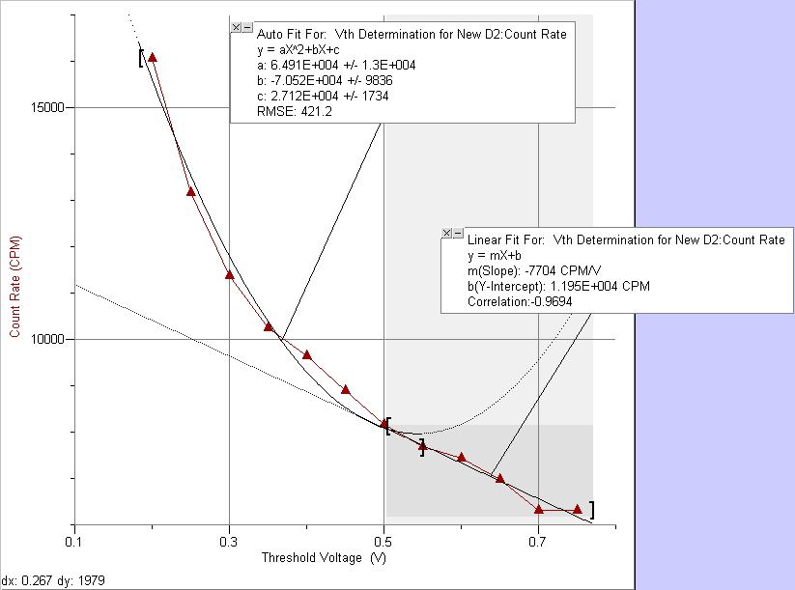

APPENDIX B – EXAMPLE OPERATING VOLTAGE OPTIMIZATION GRAPH

From this graph an operating voltage of 0.875 V was chosen. This voltage is in the middle of the directly varying region of the graph and not on the flat regions.

