Lawrence Berkeley National Laboratory
Annual Report 2024
July 23, 2024
Mentor: Tony Spadafora
Workshop Coordinator: Laurie Kerrigan
Co- Organizer: Ken Cecire & Joel Klammer (QuarkNet)

The LBNL Physics Division hosted its eighteenth “Physics in and Through Cosmology” workshop for QuarkNet Leadership teachers and high school students. This one-week in person workshop from July 8 to July 12, 2024 was held at the Lawrence Berkeley National lab. Eight physics teachers, including Workshop Coordinator Laurie Kerrigan, participated. Five of the teachers have been active members of QuarkNet and three are new teachers. There was also one retired teacher, who has been active in QuarkNet throughout his career. 37 students participated. Most of the teachers & students joined from public and private high schools in the greater San Francisco Bay Area. One student was from France.

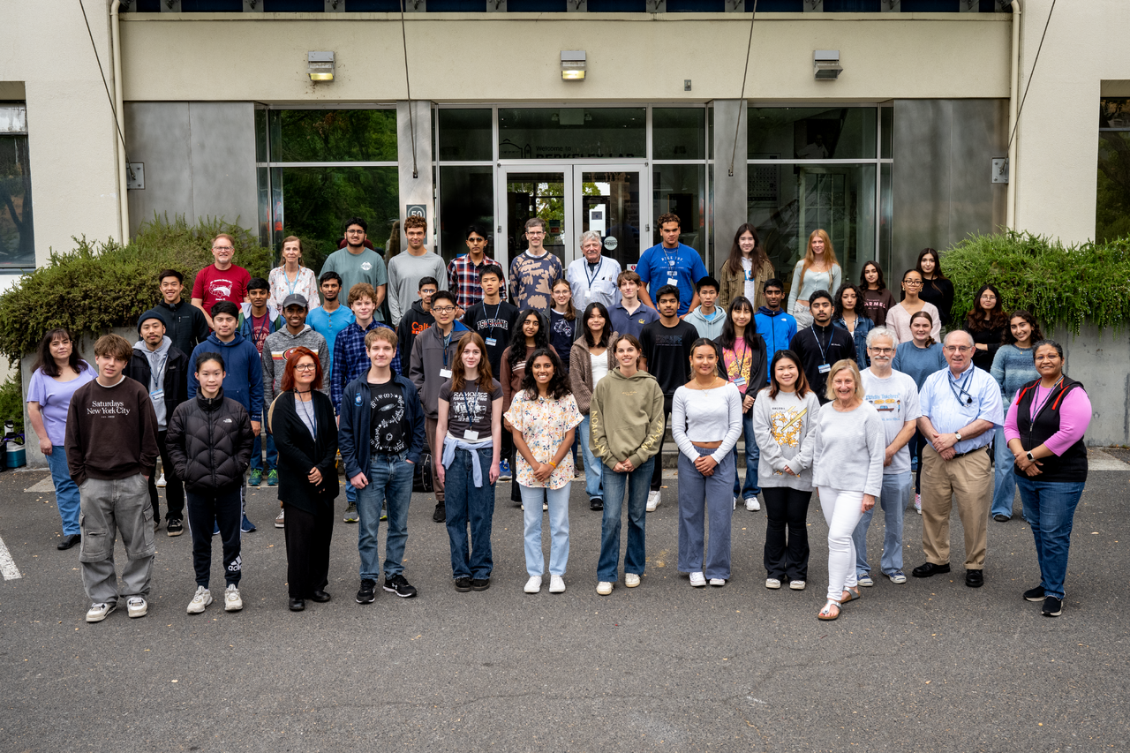
2024 QuarkNet - Physics in and Through Cosmology participants.

We have been making an effort to include underrepresented students in STEM (which include: African Americans, American Indians/Alaska Natives, Latinos, LGBTQ+, students from low income households, and first-generation college attendees) by outreaching to schools in lower income & underrepresented areas.

This year we met each weekday for one week from 8:30am-4pm. Most meetings started with a quick activity or question to get students thinking about that day’s topic. Then there was a talk by an LBL scientist and either small group work, tours, or Quarknet activities. The small group work included a Scientist Interview Project and cosmic ray detectors.
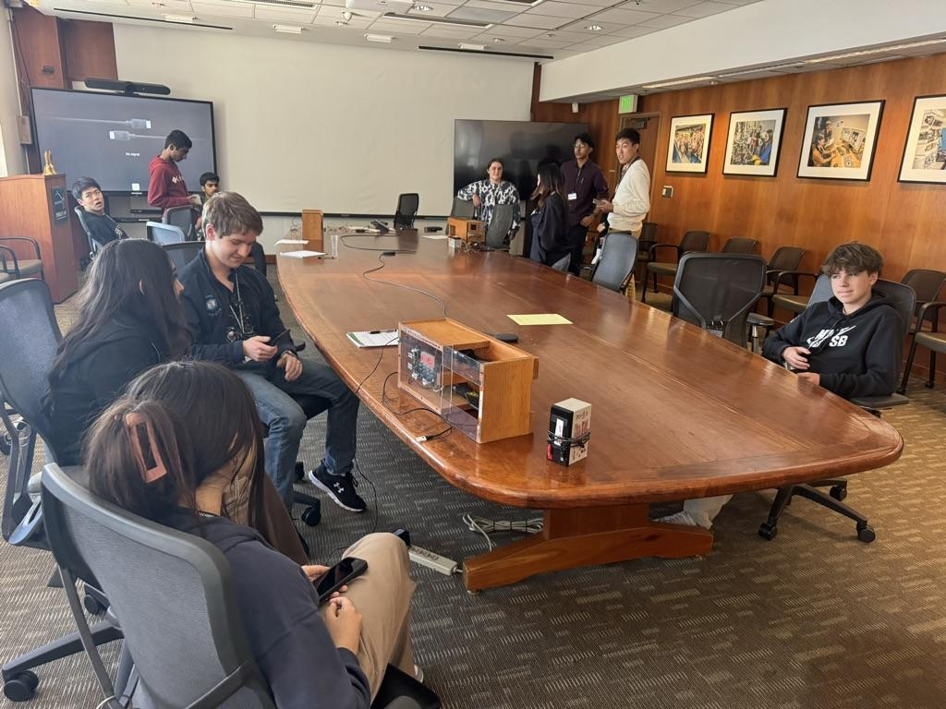
Students work with detectors.

Tours included the ALS (Advanced Light Source) and Atlas individual labs. QuarkNet activities, led by Joel Klammer included Particle Cards and Quark Workbench, Z mass measurement, and a search for the Higgs in CMS data. Glen Melnik, retired QuarkNet teacher, led the discussion on cosmic rays and how a cosmic ray detector worked in addition to directing students in their small group work with the detectors.

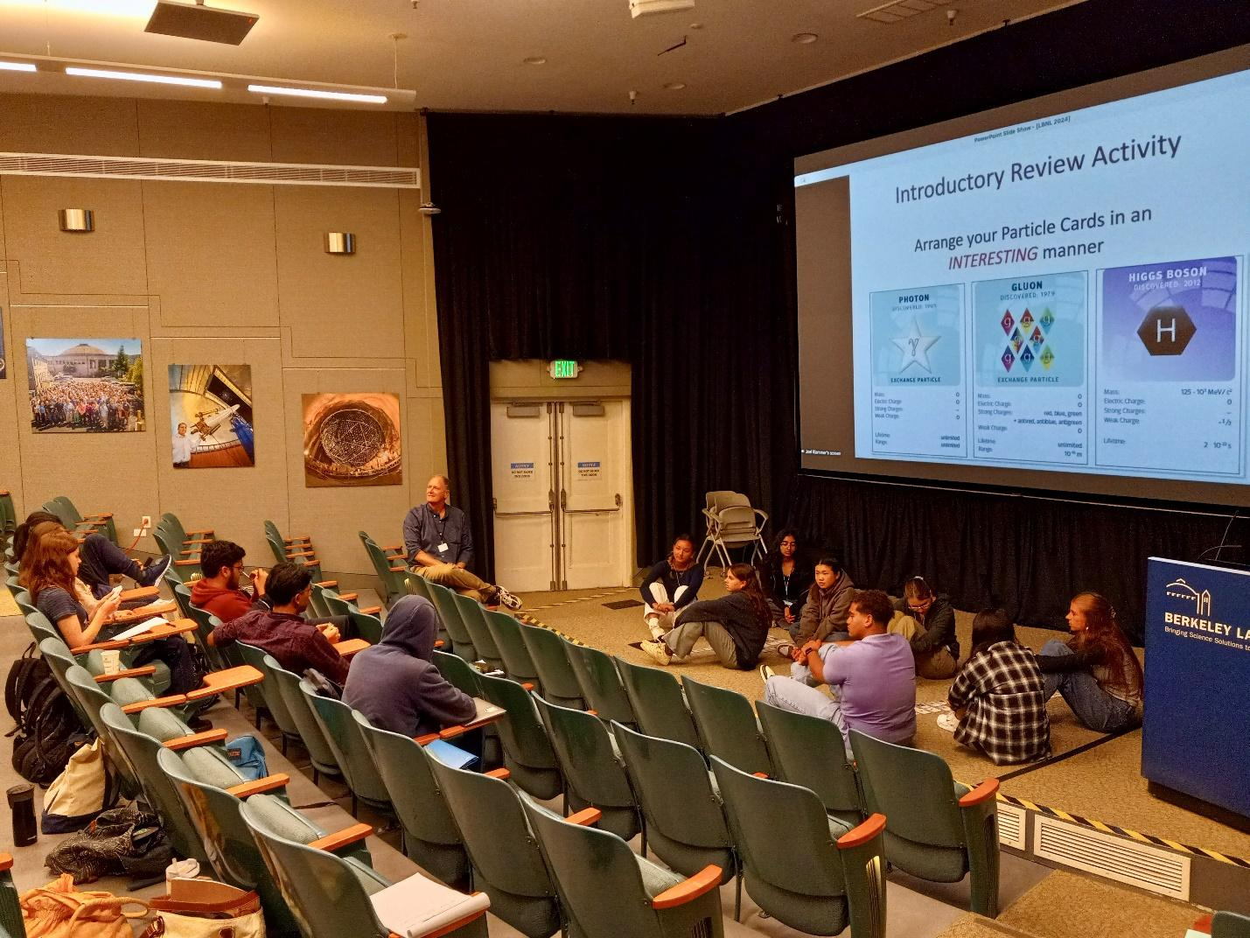

Joel Klammer (QuarkNet) leading the Particle Cards Activity discussion.
Highlights of the program were a drop in visit by Nobel Prize winner, Saul Perlmutter, and a round table panel discussion with the Scientists on the last day. Each small group presented a short video or PowerPoint about the work the Scientist they interviewed was doing.

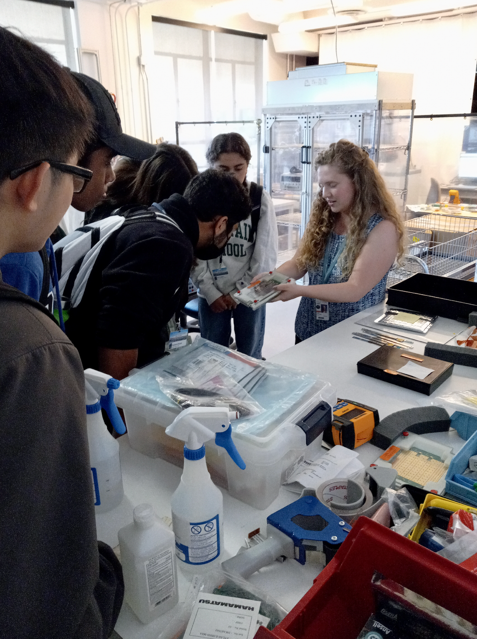

Anne Fortman (LBL) showing students some of the equipment she works on for ATLAS.

List of Teachers:
Phil Becker Sean Fottrell Laura Guthrie Laurie Kerrigan
Bryan Marten Mark Matsuzaki Dorota Sawicka Portia Sharma

Scientists interviewed by students:
Maria Mironova Anne Fortman Kevin Michael Langhoff Angira Rastogi
Laura Nosler Tsai-Chen Lee Tanvi Wamorkar Luke Grossman
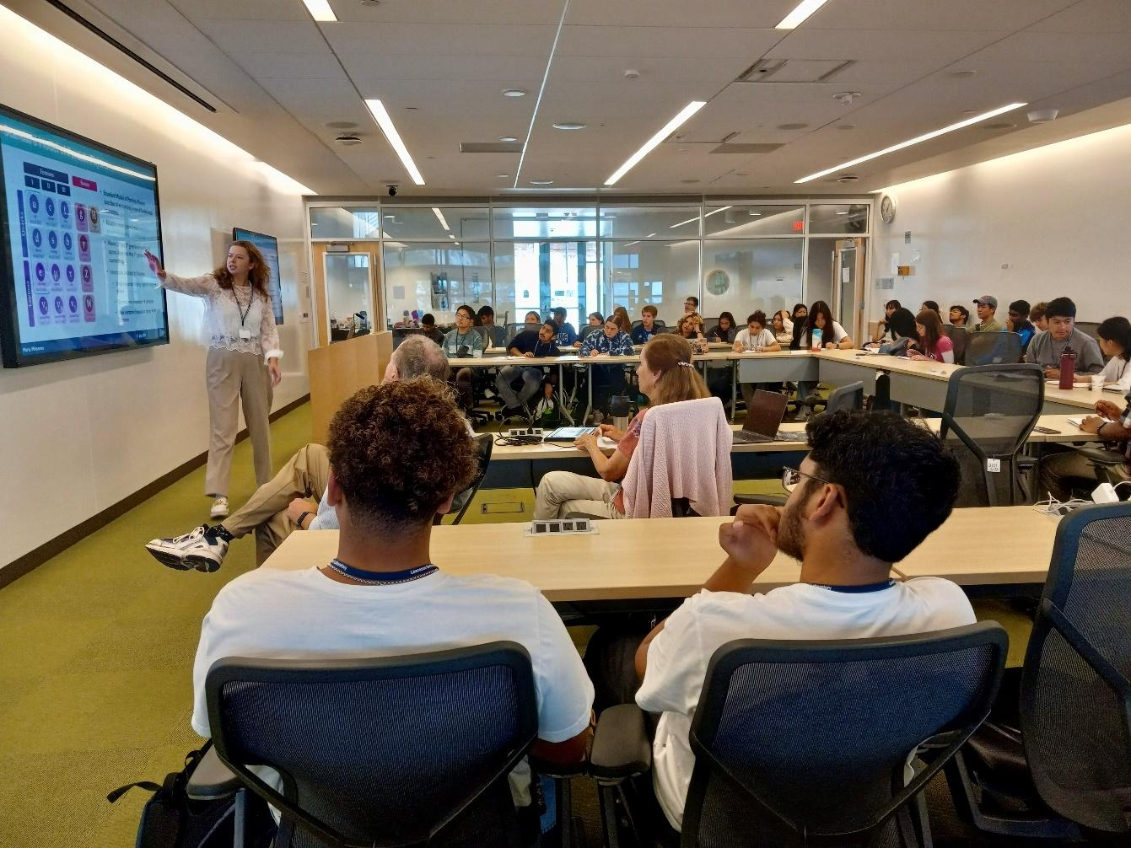

Maria Mironova (LBL) presenting "Discovering Invisible: Pixel Detectors in Particle Physics”

Formal presentations by LBNL scientists included:
Anthony Spadafora “Welcome to Berkeley Lab”
Kevin Langhoff | “The Standard Model and Beyond”
Jaafar Chakrani | "Neutrinos: a peek into the origin of the Universe?"
Giacomo Marocco | "Quantum Measurements of the Invisible"
Angira Rastogi | "Physics of photons from protons".
Dan Kodroff | "Going Deep Underground for Dark Matter"
Sascha Diefenbacher | "Machine Learning in High Energy Physics"
Maria Mironova | "Discovering Invisible: Pixel Detectors in Particle Physics”
Nicholas Rodd | "The Hunt for Dark Matter"

Comments from overall evaluations of workshop by teacher & students:
I love how we were able to have the opportunity to speak and ask “unlimited” questions with the scientists!

I really liked the interactiveness and how we were able to ask both basic and advanced questions to the researchers speaking. Most of all, I loved the tours of the lab and all the hands-on experiments we did because it gave me a feel for the careers currently in the industry and how a life in this field would like.

I really liked gaining knowledge from actual physicists about the recent breakthroughs in physics.

Hands-down--Joel Klammer and Glen Melnik were the stars of the workshop from an educator's perspective--as they demonstrated a sound grasp of the concepts being presented while simultaneously engaging their audience.

Comments by students on what they learned according to NGSS major areas in Physics:
Structure and Properties of Matter
I learned about the Standard Model of Particle Physics which was one big thing that I didn't know before and loved learning about. Learning about all those fundamental particles which make up everything we know today was so interesting and also how those particles were formed and the discovery of potentially new particles like the Higgs.

I learned about the standard model with its three generations of fermions, its leptons, and its bosons. I also learned that neutrinos cannot be subject to gravitational pull because they have too little mass and move too quickly, so they can’t be dark matter.

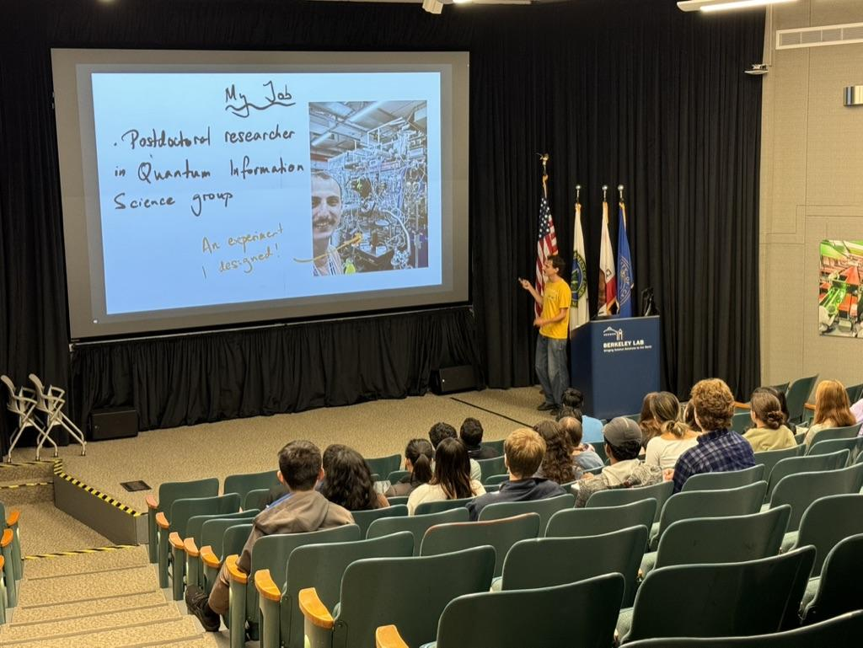

Giacomo Marocco presenting “Quantum Measurements of the Invisible”

Forces and Interactions
The four fundamental forces include weak force, strong force, electromagnetic force, and gravity. We know how weak force, strong force, and electromagnetic force work on a quantum scale: weak force is the force that is associated with beta decay , strong force keeps quarks held together and electromagnetic force is related to light and photons. Gravity is the only fundamental force that we do not know how it interacts on a quantum scale, there are theorized gravitons that are subatomic particles that make up gravity but there is no set proof that they exist.

I learned about all the different interactions with the collision of two particles like two electrons, or protons. The vast amount of particles that spread out and potentially a new particle to be discovered was very riveting and interesting to learn. I also learned about the powerful gravitational waves that form and how they could be used to track back to the beginning of the universe and calculate when that was, and also the discovery of other types of matter.

Energy
I learned about energy's conservation and how mass plays into it.

Mass-energy equivalence--as well as conservation of energy law as applied to particle collisions.

The Atlas operates at an energy of 13 TeV. With more energy, it is possible for particle colliders to create more kinds of particles.

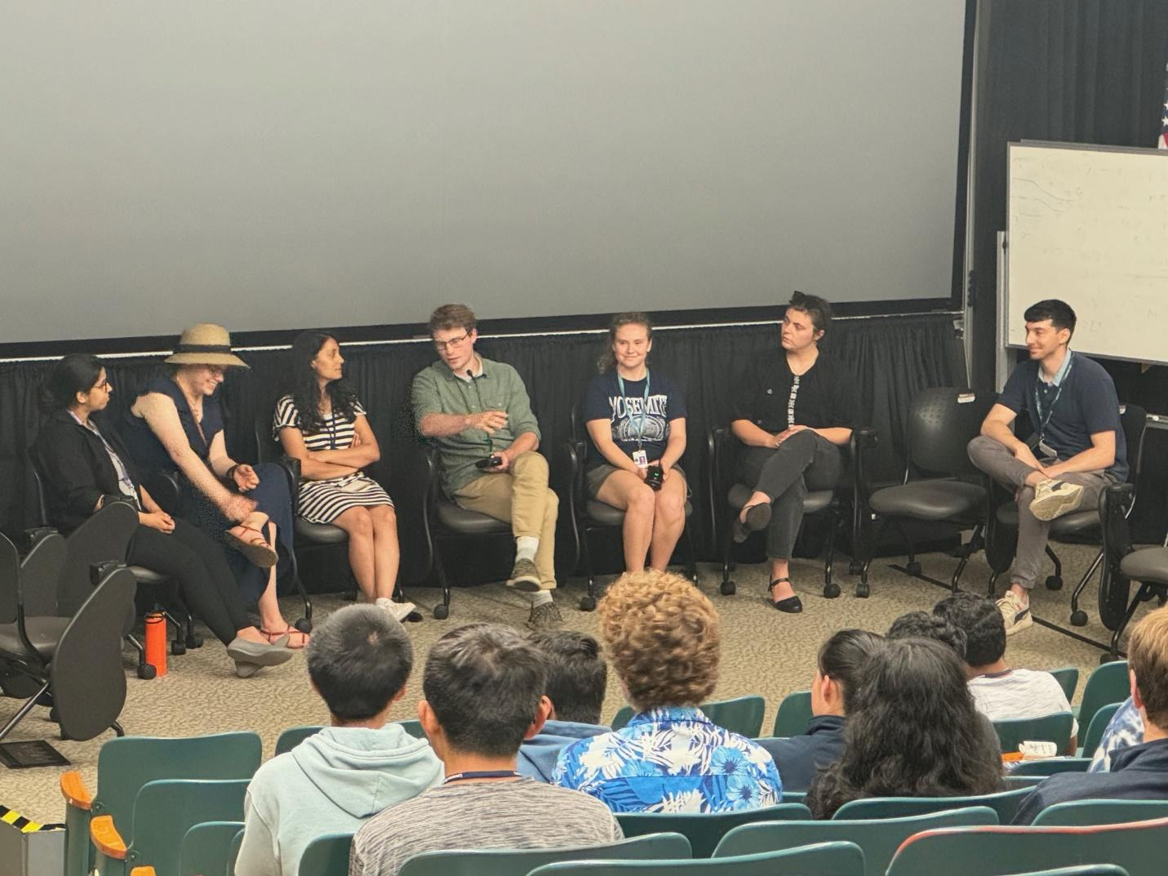
Round table discussion with LBL scientists.

Waves and Electromagnetic Radiation
The LHC produces electromagnetic waves through collisions.

I learned about the different gravitational waves and how they are important in finding and tracing back to the early universe, and also how electromagnetic radiation is represented as a stream of packets or quanta of energy, called photons, that travel in straight lines.

Engineering Design
I saw how different chips and sensors were designed through an engineering perspective.

How to design and build muon detectors and how large-scale projects like ATLAS at the LHS function.

One thing which was super interesting to learn was the vast number of silicon chips needed for all the trackers and detectors and also the precise building of the circuits, chips, and devices needed for ATLAS, LHC, and quantum computers. I also learned about ATLAS and LHC for the first time and the size comparison and the engineering design needed to create such a massive particle accelerator. It was very interesting to see the silicon chips and how they needed to be in cold temperatures and the detailing needed to be super exact, so no mistakes were made and every proton, positron, electron, etc can be captured and collected as data.

