How to Construct a Concept Map
What does it mean when you say, I understand?.... Does it mean the same thing to you as it does to another student or your teacher?..... How can you demonstrate your understanding? Constructing a concept map provides a way to expose, reflect on, deepen, and share your understanding.
What is a concept map?: A concept map presents the relationships among a set of connected concepts and ideas. It is a tangible way to display how your mind "sees" a particular topic. By constructing a concept map, you reflect on what you know and what you don't know. In a Concept Map, the concepts, usually represented by single words enclosed in a rectangle (box), are connected to other concept boxes by arrows. A word or brief phrase, written by the arrow, defines the relationship between the connected concepts. Major concept boxes will have lines to and from several other concept boxes generating a network. There are many sites on the Internet that provide additional background on Concept Maps.
Constructing a Concept Map
Brainstorming Phase: From your memory, (which you can jog by going through your notes and related course material) identify facts, terms, and ideas that you think are in anyway associated with the topic. [For example: Make a list of these items and print them neatly on small Post-It® notes, one per note, in very brief form, i.e. a single word or short phrase.] This is a brain-storming process, so write down everything that anybody in your group thinks is important and avoid discussing how important the item is. Don't worry about redundancy, relative importance, or relationships at this point. Your objective here is to generate the largest possible list you can. Before your group completes this step, you may have more than 50 items.
Organizing Phase: Spread out your concepts (Post-It® notes) on a flat surface so that all can be read easily and, together, create groups and sub-groups of related items. Try to group items to emphasize hierarchies. Identify terms that represent those higher categories and add them. Feel free to rearrange items and introduce new items that you omitted initially. Note that some concepts will fall into multiple groupings. This will become important later.
Layout Phase: On a large sheet of paper, try to come up with an arrangement (layout) that best represents your collective understanding of the interrelationships and connections among groupings. Feel free to rearrange things at any time during this phase. Use a consistent hierarchy in which the most important concepts are in the center or at the top. Within sub-grouping, place closely related items near to each other. Think in terms of connecting the items in a simple sentence that shows the relationship between them. Do not expect your layout to be like that of other groups. It may be advisable to meet outside of class to work on this assignment and plan for its completion.
Linking Phase: Use lines with arrows to connect and show the relationship between connected items. Write a word or short phrase by each arrow to specify the relationship. Many arrows can originate or terminate on particularly important concepts.
Finalizing the Concept Map: After your group has agreed on an arrangement of items that conveys your understanding, you need to convert the concept map into a permanent form that others can view and discuss. Be creative in a constructive way through the use of colors, shapes, border thickness, etc. to communicate your group's understanding. Give your concept map a title. In reviewing your concept map, consider the following attributes:
- Accuracy and Thoroughness. Are the concepts and relationships correct? Are important concepts missing? Are any misconceptions apparent?
- Organization. Was the concept map laid out in a way that higher order relationships are apparent and easy to follow? Does it have a title?
- Appearance. Was the assignment done with care showing attention to details such as spelling and penmanship? Is it neat and orderly or is it chaotic and messy?
- Creativity. Are there unusual elements that aid communication or stimulate interest without being distracting?

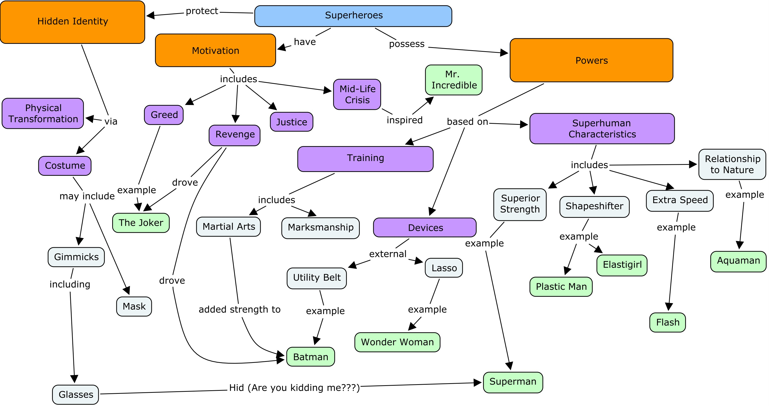
NOTE: You MAY NOT use your computer at any time while working on this assignment. You may use your notes and your Particle Adventure work to help you in completing your concept map.

