SEISMOLOGY UNIT

Course: Middle School Earth Science
Topic: Seismology
Grade: 7-9
Duration: 8, 45-minute sessions; LIGO e-Lab 7, 45-minute sessions including 5 to conduct e-lab and 2 days for student presentations.

The purpose of the unit is to prepare students to effectively engage in the LIGO e-lab.

Table of Contents

Teacher Information
Overview
Background Information
Enduring Understandings
Previous Learning
Resources
Preparation
Standards
National Science Education Standards (NRC)
Common Core — English
Common Core — Math
ESL Strategies
Assessment

Activities
1
Launch Activity: Seismology, the study of earth’s movements
Sidebar: Can animals detect earthquakes?

2
Exploration: Finding patterns in seismograms generated by earth movement

3
Explain Phenomena: Seismogram characteristics and features

4
Extend Knowledge: Earthquake Waves

Sidebar: Geologist study earth’s interior

5
Bridging Activity: LIGO e-Lab
Sidebar: Einstein’s Messengers Video
6
LIGO Project

Overview
In this unit students engage in a learning sequence culminating in a long-term project, the LIGO e-lab. This unit engages students in becoming amateur seismologists. Using hands-on, minds-on activities, students learn what creates waves caused by earth movements, how to interpret seismograms, and how to develop a research project using seismographic data. At the end of the unit, students present their research through poster presentations.
The focus of the unit is on seismology, the study of earth movements and vibrations caused by shifting of tectonic plates, ocean wave action, and human activity. All this movement creates waves that are measured with seismographs (the instrument), which create seismograms (the data display). Seismologists study these seismograms and long-term records of seismic activity in order to know more about mass movement—predominantly earthquakes. Geologists use the data to study composition of the earth. As students develop understanding of seismology and measurement, they can begin to investigate seismic waves using LIGO’s seismic data. Students can apply seismology concepts to explore how the ground shakes underneath LIGO’s huge gravitational wave detectors.
Activities in the unit, and particularly the e-lab, provide opportunities for students to engage in scientific collaboration through inquiry using technology. Therefore, the scope of the unit addresses multiple science, technology and even mathematics and language arts standards (see below).
Eight 45-minute sessions prepare students for the e-lab; students conduct the e-lab in five 45-minute sessions; two 45-minute sessions for students to present their posters to the rest of the class.

Background Information
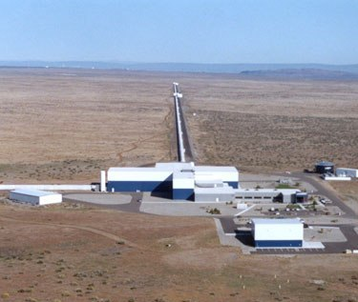
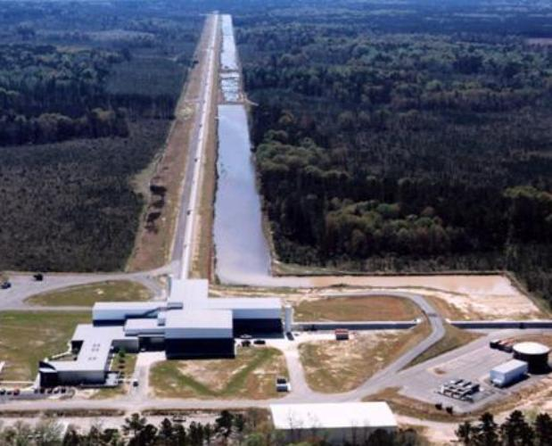
In this unit students will work through the conceptual basics of seismology: the nature of seismic waves, their causes, and how to detect them. The unit sets the stage for student investigations of seismic waves in an interesting context: the LIGO Project.

The LIGO detector in Hanford, Washington (left) and Livingston, LA (right)
At LIGO (in both its Washington State and Louisiana facilities), scientists are attempting to hold mirrors remarkably still at a great distance apart, measuring the distance between them carefully. Using lasers in a technique called interferometry, they are carefully monitoring the distance between these mirrors, looking for a particular kind of wave—a gravitational wave—to change the distance between them. In order to detect those gravitational waves, all other sorts of disturbances of these mirrors—including those caused by seismic waves must be carefully monitored so that LIGO can filter out the influence of these waves from the gravitational wave detectors. For this reason, LIGO scientists monitor—constantly measure—seismic waves in the areas where their mirrors are located. While LIGO’s research is on detecting gravitational waves from outer space, the “noise” created here on Earth enables students to explore that same LIGO seismic data, finding the same seismic wave patterns that scientists at LIGO must be so careful to identify, isolate or minimize.
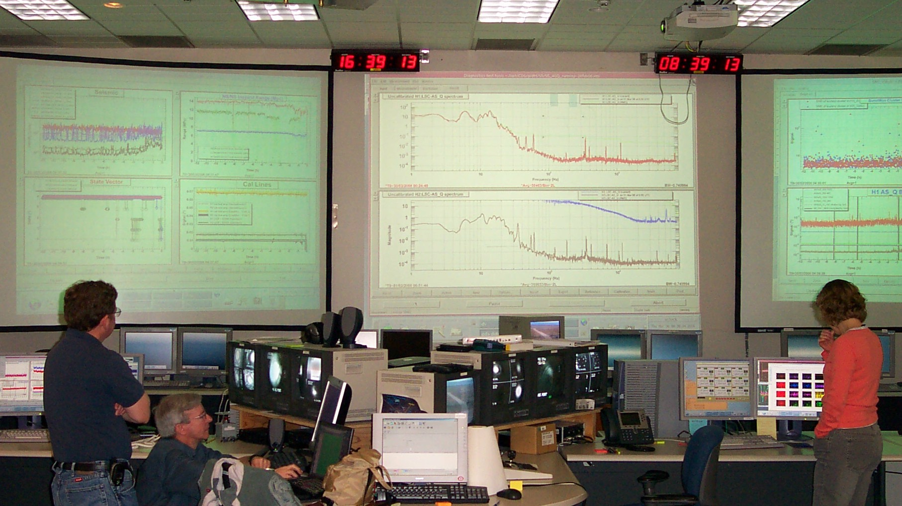
But to join in this search, students must understand some basic seismology (the purpose of this preparatory unit.) Many events can produce some shaking of the ground. The chief cause of major seismic activity, such as earthquakes, is the fact that we live on Earth’s crust, which floats upon molten rock, all surrounding a spinning solid core. Pressure builds up in the crust hovering over that dynamic system, and when that pressure produces movement, the resulting vibrations are transmitted as seismic waves. Students must be able to explain this buildup of pressure, and use the language of waves (wavelength, frequency, amplitude, period, arrival time) to explain how energy is transferred around the globe from the release of that pressure. They should be able to give examples of different types of waves (surface waves, body waves P and S), providing examples of factors that affect the speed (density of medium) and direction (refraction, reflection) of these waves. Students should be able to recognize the signatures of various seismic waves in seismograms produced by seismographs, and distinguish seismic signatures from other kinds of disturbances recorded by these instruments.

LIGO Hanford Observatory detector control room.
The screen on the right shows plots from LIGO seismometers.

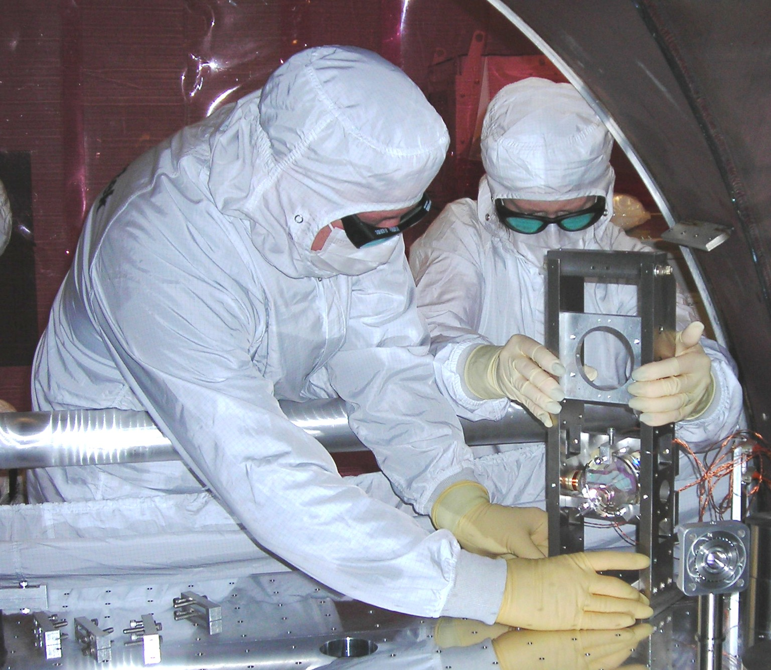
Below: LIGO personnel install a small optic in a gravitational wave det

Enduring Understandings
1) There are several kinds of waves in nature that can be detected and measured through various means both natural (ear detecting compression waves called “sound”) and with instruments (e.g., seismographs, interferometers).
2) Waves are the manifestation of energy moving through a medium.
3) Movement of energy through earth materials is detected by a seismograph and displayed with a seismogram.
4) Waves travel at different velocities depending on the materials they are moving through (an important factor in learning about earthquakes and composition of the earth).
5) Seismogram readings look different depending on the source of the waves.

Previous Learning
Skills | Developing research questions; identifying variables  Measurement and descriptions of motion and energy  Graphing of one or more variables
Concepts | Composition of earths’ crust  Plate tectonics  Properties of earth materials such as soil, sand, clay and soil moisture  Force, energy and motion. The grade 5-8 National Science Education Standards include: Motion and Forces—The motion of an object can be described by its position, direction of motion, and speed. That motion can be measured and represented on a graph. Energy—Energy is a property of many substances and is associated with heat, light, mechanical motion, sound, nuclei, and the nature of a chemical. Energy is transferred in many ways.

Resources
Access to a computer lab, bank of computers, or classroom computers is essential to conduct the e-lab and use Internet resources.
LIGO e-lab. We encourage you to explore the tools and resources in the LIGO e-lab at www18.i2u2.org/elab/ligo/home/. Log on as “guest” to explore the site without registering.
The Hanford and Livingston LIGO research sites include background information and video resources. http://www.ligo-wa.caltech.edu/ligo_overview.htm
An especially powerful video is Einstein’s Messengers at http://www.ligo.caltech/edu.
The Get Started section of the e-lab includes many resources including the following:
United States Geological survey (USGS) http://earthquake.usgs.gov/. Look at the student and teacher resources, seismograms with an illustrative example to see how to interpret the seismograms (http://earthquake.usgs,gov/monitoring/helicorders/examples/Fore_main_after.php). Choose a site, then click on a particular day to enlarge the seismogram.
See www.exploratorium.edu/faultline for educational information including basic information and a video of a gelatin San Francisco to see the effect of earthquakes on buildings.
Incorporated Research Institutions for Seismology (IRIS) www.iris.edu has educational resources including one-page handouts on various topics such as how a seismometer works. The site includes seismic data and seismogram images.
This is a site at a higher cognitive level that will need some teacher guidance for students to use. It includesnformation on wave travel times and speeds as well as information on waves traveling through different mediums (water, solids of different densities). http://eqseis.geosc.psu.edu/~cammon/HLML/Classes/IntroQuakes/notes/waves_and_interior.html
Tabletop seismometer. It is essential for students to have some experiential evidence for the seismogram generated by a seismograph. Use of a complex seismograph is not necessary; it is possible to build, or have students build a simple seismograph. The following web sites provide a variety of possibilities:
Using a Mac laptop computer – www.suitable.com/tools/scimac.html
Using simple, easy-to-obtain materials - http://pbskids.org/zoom/activities/sci/seismometer.html
The Teacher’s Domain web site has a video that shows students how to construct this simple seismometer at http://www.teachersdomain.org
For something more complex, but more authentic, try http://cse.ssl.berkeley.edu/lessons/indiv/davis/hs/Seismograph.html
If you want to buy a tabletop seismometer, look at www.iris.edu/hq/sis/resources/seismometers#2
To use the Vernier force and motion probes, see Appendix A in this document.
Science Notebook. Use of a scientific notebook is recommended. The e-lab uses an on-line notebook system. One site for reviewing use of science notebooks in K-12 classrooms is http://sciencenotebooks.org, which includes links for setting up and organizing science notebooks.

Preparation
Build or obtain a seismometer (see resources, above).
Walk through the LIGO e-lab as a student to become familiar with the structure and content of the e-lab (www18.i2u2.org/elab/ligo/home/).
Review LIGO e-lab teacher resource pages at http://www18.i2u2.org/elab/ligo/teacher/

National Science Education Standards
(National Research Council)
Content: Structure of the Earth System | Lithospheric plates on the scales of continents and oceans constantly move at rates of centimeters per year in response to movements in the mantle. Major geological events, such as earthquakes, volcanic eruptions, and mountain building, result from these plate motions.
Science and Technology | Perfectly designed solutions do not exist. All technological solutions have trade-offs, such as safety, cost, efficiency, and appearance.
Science in Personal and Social Perspectives | Internal and external processes of the earth system cause natural hazards, events that change or destroy human and wildlife habitats, damage property, and harm or kill humans. Natural hazards include earthquakes, landslides, wildfires, volcanic eruptions, floods, storms, and even possible impacts of asteroids.
Science as a Human Endeavor | It is part of scientific inquiry to evaluate the results of scientific investigations, experiments, observations, theoretical models, and the explanations proposed by other scientists, Evaluation includes reviewing the experimental procedures, examining the evidence, identifying faulty reasoning, pointing out statements that go beyond the evidence, and suggesting alternative explanations for the same observations.
Inquiry | Identify questions that can be answered through scientific investigations.  Design and conduct a scientific investigation. Use appropriate tools and techniques to gather, analyze, and interpret data.  Develop descriptions, explanations, predictions, and models using evidence.  Think critically and logically to make the relationships between evidence and explanations.  Recognize and analyze alternative explanations and predictions.  Communicate scientific procedures and explanations.  Use mathematics in all aspects of scientific inquiry.

Common Core Standards
English Language Arts
Writing Standards, Production and Distribution of Writing | Produce clear and coherent writing in which the development, organization, and style are appropriate to task, purpose, and audience.  With some guidance and support from peers and adults, develop and strengthen writing as needed by planning, revising, editing, rewriting, or trying new approach.  Use technology, including the Internet, to produce and publish writing as well as to interact and collaborate with others.
Research to Build and Present Knowledge | Conduct short research projects to answer a question, drawing on several sources and refocusing the inquiry when appropriate.  Draw evidence from literary or informational texts to support analysis, reflection, and research.
Range of Writing | Write routinely over extended time frame (e.g. time for research).
Speaking and Listening, Comprehension and Collaboration | Engage effectively in a range of collaborative discussions… building on others’ ideas and expressing their own clearly.  Delineate a speaker’s argument and specific claims, evaluating the soundness of the reasoning and the relevance and sufficiency of the evidence.
Presentation of Knowledge and Ideas | Present claims and findings, emphasizing salient points in a focused, coherent manner with pertinent descriptions, facts, details, and examples; use appropriate eye contact, adequate volume and clear pronunciation.
Conventions of Standard English, Knowledge of Language | Use knowledge of language and its conventions when writing, speaking, reading or listening.

Common Core Standards
Mathematics
Ratios and Proportional Relationships | Compute fluently with multi-digit numbers and find common factors and multiples.
The Number System | Understand a rational number as a point on the number line. Extend number line diagrams and coordinate axes familiar from previous grades to represent points on the line and in the plane with negative number coordinates.  Solve real-world and mathematical problems by graphing points in all four quadrants of the coordinate plane. Include use of coordinates and absolute value to find distances between points with the same first coordinate or the same second coordinate.
Statistics and Probability | Understand that a set of data collected to answer a statistical question has a distribution, which can be described by its center, spread, and overall shape.  Summarize numerical data sets in relation to their context

National Educational Technology Standards
(International Society for Technology in Education)
Performance Indicators | Apply strategies for identifying and solving routine hardware and software problems that occur during everyday use.  Use content-specific tools, software and simulations…to support learning and research.  Apply productivity/multimedia tools and peripherals to support personal productivity, group, collaboration, and learning through the curriculum.  Design, develop, publish, and present products…using technology resources that demonstrate and communicate curriculum concepts to audiences inside and outside the classroom.  Collaborate with peers, experts, and others using telecommunications and collaborative tools to investigate curriculum-related problems, issues, and information, and to develop solutions or products for audiences inside and outside the classroom.  Select and use appropriate tools and technology resources to accomplish a variety of tasks and solve problems.  Demonstrate an understanding of concepts underlying hardware, software, and connectivity, and of practical applications to learning and problem solving.

ESL Strategies
The unit includes several strategies that are recommended for use with English Language Learners (from: 2004, Fifty Strategies for Teaching English Language Learners, A. Herrell and M. Jordan; Pearson, Prentice-Hall: Upper Saddle River, NJ). These include:
- Advance Organizers—objectives, “big ideas”
- Cooperative/Small Group Learning—students conduct activities and project in groups
- Integrated Curriculum—Multiple disciplines, authentic project
- Word Wall—organizing concepts and vocabulary for easy access
- Graphic representation—organizing information
- Closure—reinforcing major concepts and principles
- Multimedia—videos, computer, hands-on materials

Assessment
The e-lab has several rubrics and assessments that relate to the project objectives (Content & Investigation, Process, Computing, Literacy and Poster). See http://www18.i2u2.org/elab/ligo/teacher/. The following are suggestions and resources for assessing products produced during the unit and the e-lab.
Notebooks | There are online notebooks as part of the e-lab. Suggestions for this unit also include students writing in science notebooks. Research has shown that if teachers make occasional comments in student notebooks and/or grade notebook entries, use of notebooks are more effective.
Discussions | Provide an opportunity for formative assessment (assessing student understanding during the unit). Randomly selecting students to address a discussion point, asking students to occasionally write an answer on individual white boards, or using active responders helps to assess the extent to which all students are engaging in the process and have understood the concepts to the extent that the class can move to the next section of the unit. It might also be helpful to have occasional discussions during the e-lab as students work their way through the milestones. The on-line notebook entries could provide clues as to when a whole-class discussion (“milestone seminars”) might improve understanding.
Presentations | A comprehensive rubric that you can draw from can be found at http://serc.carleton.edu/NAGTWorkshops/assess/oralpresentations.htm
Graphic representations | You can develop a rubric or assess major aspects of the representation:  Source type and image—is the image an accurate representation of the source type?  Characteristics of the graph—is the evidence to support the graph as created by the source type clear and the description accurate?  Examples—is there more than one example? Are they appropriate examples? Are diverse (two or more different) examples represented?  Non-examples—do the non-examples show characteristics that clearly make them non-examples?

1
Launch Activity: Seismology, the study of earth’s movements

Big Idea
Earthquakes are the result of mass movements of the earth creating waves that are propagated through the earth and detected with instruments. Waves create destructive effects on the surface of the earth in proportion to the magnitude. (Later students will also learn that destructive effects are also different depending on the type of wave e.g., shear, primary, surface.)
Enduring Understanding focus on #1
Learning Objectives: Students will be able to:
- list words—technical, descriptive—based on observations.
- use online resources for collecting observational data; compare/contrast observational data.
3. match different kinds of waves with the instruments used to detect them.

Time: One 45-minute period
• 10-minute introduction—set up science notebook; describe task
• 25 minutes online research
• 20 minutes closure including small-group discussion; assess prior knowledge

Resources
USGS Web site http://earthquake.usgs.gov/
YouTube has numerous videos of earthquakes including some from the National Geographic Society
http://topics.cnn.com/topics/earthquakes
http://videos.howstuffworks.com/science/earthquake-videos-playlist.htm (note - this site has commercials before the video plays)
www.exploratorium.edu/faultline also has videos available

Action
For this first activity, students watch videos and access Internet resources to access their prior knowledge and develop common experiences and vocabulary related to earthquakes and the science of seismology.
Tell students to write words in their science notebooks about how earthquakes are being described and words about how earthquakes are measured. They can describe in their own words what they see in videos (focus their attention on motion).

Creating a Word Wall
While it is important to not focus on defining words, for now, you can create a “Word Wall” for terms the class will be using throughout the unit. Later you can sort technical words (e.g., magnitude, amplitude, shear) from descriptive words (e.g., sway, vibrate). Interestingly, “shake” turns out to be a technical term. A Word Wall is a particularly effective strategy for English Language Learners (ESL’s).

Discussion/Closure
Students will notice that “waves” are often discussed in relation to earthquakes. Have them discuss, in small groups, what kinds of waves they know about and how the waves are detected. In a whole group discussion, encourage students to share ideas about waves being detected through our bodies (light-eyes, sound-ears). Also discuss that waves can be detected with instruments (at least some students will discover the term ‘seismograph’ through their online research; again, note that sites tend to vary in their use of terms—a seismograph might also be called a “seismometer.”).
During discussions start using technical terms so students get used to hearing them, but do not have students write down or define terms yet. Encourage them to use technical terms if they seem to understand them.

Sidebar

Some say animals can detect earthquakes or other natural disasters before they happen. While there is no scientific evidence for animals predicting earthquakes, it is possible that animals feel vibrations or earthquake foreshocks not detected by humans. It is also possible animals perceive changes in air pressure that occur before an earthquake. The main point for this unit is that animals may detect small-scale compression waves and/or electromagnetic waves that humans cannot detect therefore they react to an impending event. For further information access:

http://news.nationalgeographic.com/news/2003/11/1111_031111_earthquakeanimals.html

http://www.pbs.org/wnet/nature/episodes/can-animals-predict-disaster/introduction/130/ about animals detecting natural disasters, also includes a video.

2
Exploration: Finding patterns in seismograms generated by earth movement

Big Idea
Students understand that the seismograph records earth movements with precise measurements. Different types and strengths of movements have characteristic seismograph “traces.”
The key to this lesson is that students get to observe the traces of their “earth movements” in real time. This real-time feedback enables them to physically and cognitively understand the changes recorded in the seismogram.
Enduring Understandings #1, 2, 3, 5
Learning Objectives: Students will be able to
- Interpret traces for various movements that originate the seismogram—direction, magnitude
- Compare and contrast seismograms from different sources; describe patterns.

Time: Two 45-minute periods
If you have only one computer or seismograph, run an alternative activity for small groups while each takes a 10-minute turn at the equipment.
10 minute introduction
40-50 minutes exploration and writing in notebooks
35 minute closure; allowing time for additional exploration and writing in notebooks

Resources
SeisMac software for Macintosh or PC portable computer. The computer needs to have a built-in motion sensor. An alternative is to use the Vernier software and Motion Probe for this activity.
Placing the computer on a rolling cart allows students to simulate dramatic movement of each kind of seismic wave, as well as regular “rumbling” of wheels over a rough surface.
You may want to assign one or more of your most dramatic students to shout “Godzilla!!!” at appropriate moments of high-energy earth movement.

Action
Set up or have students set up the tabletop seismograph. Have students gather around the demonstration table. While they are very still, make an initial seismogram. That will be the baseline.
If you are using SeisMac, note that there are three simultaneous graphs produced: a Z-axis, y-axis and x-axis. Note in the above diagram that the x-axis records compression waves propagating from the source. In SeisMac, the x-axis represents side-to-side movement, the y-axis represents back-and-forth movement, and the z-axis represents vertical change (up and down). Challenge students to figure out what direction of motion each axis represents. Here are three we made:
Figure 1: Moving up and down
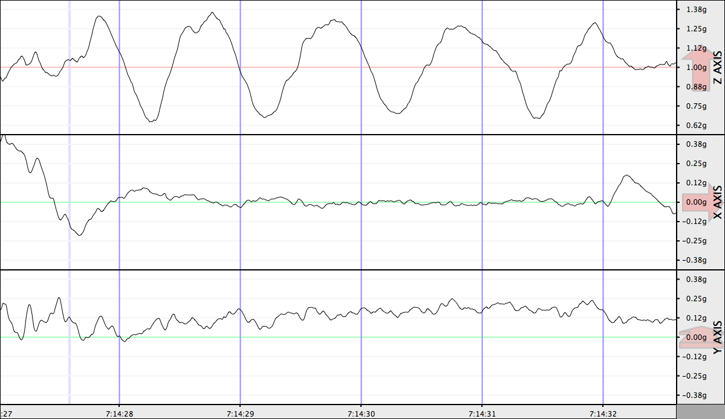
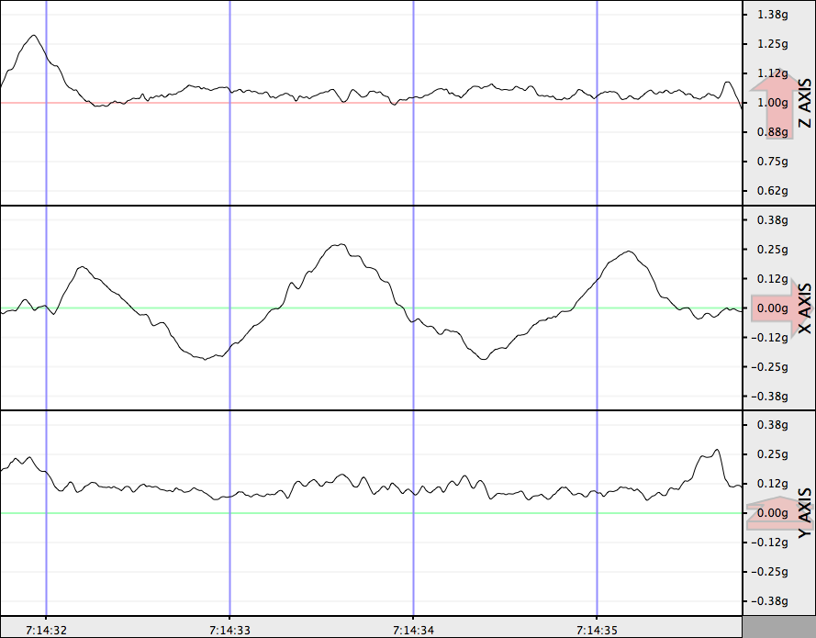
Figure 2: Moving side to side
Figure 2: Moving side to side

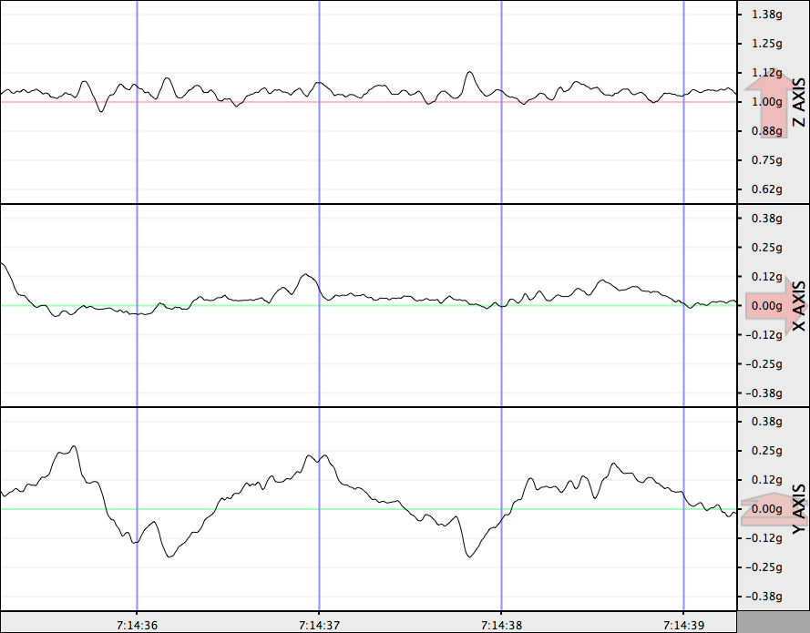
Figure 3: Moving back and forth

Then have students jump up and down with various frequencies and at various places in the room. They can also shake the table or surface on which the seismograph sits. If possible, push a heavy cart near the seismograph and/or take it outside or in the parking lot to record the effect of a car or truck passing by.
Keep the seismograph on the table for further exploration depending what emerges in the discussion and closure.
Make sure a student is making note of what is happening when each of the seismogram is being recorded. Display the seismograms along with the notes on what was the cause or source of the waves. Ask them to take notes in their notebooks then reflect on how the waves changed based on what caused the wave. Encourage students to look for patterns in the data (e.g., Do the ‘shake’ seismograms look different than the ‘jumping’?)

Closure
Ask students to report out some of the things they wrote in their reflections. Try to get students to build on one another’s comments instead of just reporting out without connecting their ideas to others’. Make sure students are linking their behaviors (jumping) to the seismograms.
As during closure for the Launch activity, during discussions start using technical terms so students get used to hearing them, but do not have students write down or define terms yet. Encourage them to use technical terms if they seem to understand them.

Other images from our “messing around”

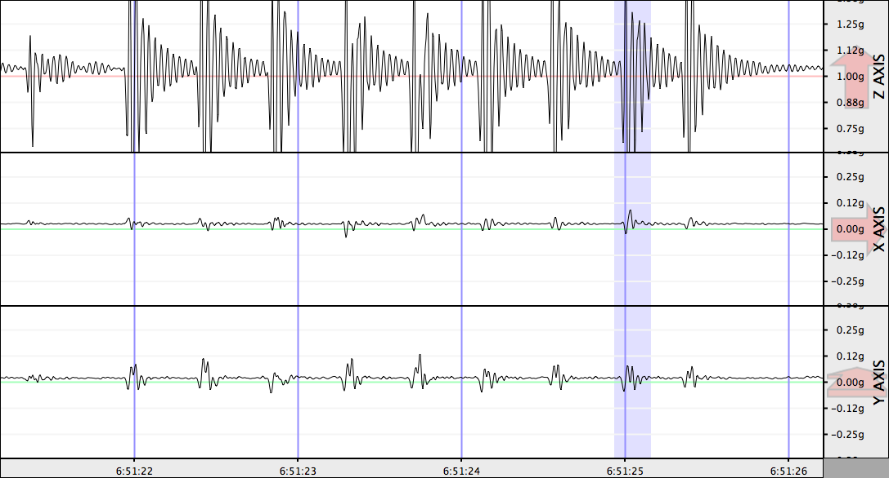
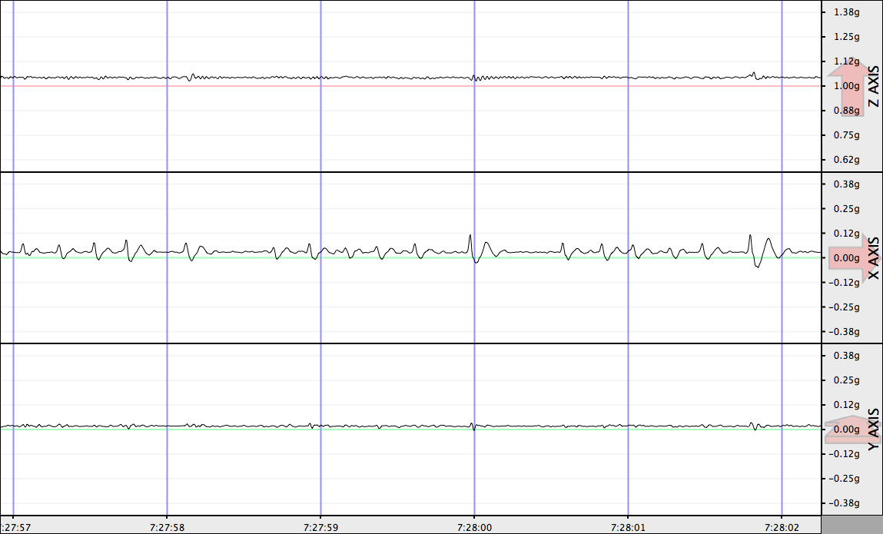
What’s Z Matter?

Rumba on the x-axis

3
Explain Phenomena: Seismogram characteristics and features

Big Idea
Seismograms from different sources have identifiable patterns and features. Seismologists use specific language in describing seismic waves and how they are measured. Seismic waves have similar features as all waves.
Enduring Understandings #1, 2, 3, 5

Learning Objectives
Students will be able to
- identify the source of earth movements by interpreting seismograms.
- support their claims with evidence and provide reasoning for their evidence.
- use correct terminology to describe seismogram features.

Time: Three 45-minute periods
25 minute introduction, labeling
45 minutes to prepare presentations
35 minutes for presentations
30 minutes for closure

Resources
Print out or access online a variety of seismograms. Some examples are shown, below. Online sources can be accessed at:
Google images – seismograms. Although most of these seismographic images are of earthquakes, there are also seismograms of events such as buses passing by a seismograph, explosions, and “mystery events.” These other events are most likely to be located further down on the page.

Action
Day One
Have students look at seismograms from a variety of sources including those they created during Exploration, earthquakes, other natural phenomena, and human-made events. Have students point out and sketch features of the seismograms in their notebooks; have them label features of the waves using the technical/scientific terms on the Word Wall. If possible have students access Google images-seismograms, to look at a large variety of images. Ask them to sketch and label three or four seismograms generated by different sources, not just earthquakes. Several Google image seismograms generated by earthquakes include p and s was as well as surface wave labels. These can be used in Lesson 4. The students have had a lot of experience with waves, how they are generated and measured. At this point, they have a good grasp of the concepts and only have to give names to characteristics and features with which they have become familiar.

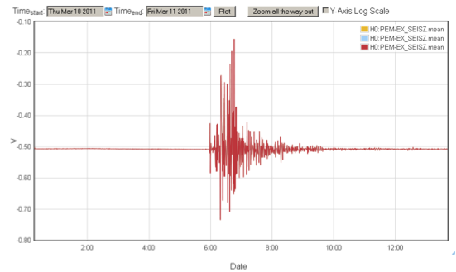
March 11, 2011: Japan magnitude 9.0 earthquake as seen on a seismometer at LIGO Hanford Observatory

Day Two and Three:
Assign groups of students one source type: earthquakes, volcanoes, explosions, trucks or whatever else they may have found in Day One. Have students develop graphic representations as follows: on a sheet of paper draw four quadrants. In one quadrant put the seismogram source type + image; in the second, characteristics of the graph; in the third include one or more other examples; in the fourth include non-examples.
Each group then displays their papers according to the type of seismogram they were assigned. Have them present their papers (graphic representations) to the class. Encourage them to use scientific language. Encourage them to support claims with evidence such as explain why the image they chose is an example, and then contrast characteristics of non-examples.

Closure
Focus on features of waves that include frequency, amplitude. Ask them to compare magnitude and amplitude. Ask students to discuss differences among seismograms, especially the sensitivity of the seismometer to movements of different types of motion at different intensities. Have them draw examples in their notebooks and reflect on the differences.
Terminology students should be using at this point includes:
Related to all waves – amplitude, frequency, wavelength, velocity
Related to earthquake waves — body waves – P and S, surface waves
Earthquakes/mass movement measures — Richter scale; magnitude

4
Extend Knowledge: Earthquake Waves

Big Idea
Seismograms of the same earthquake may look different because of variables affecting waves generated by the event and distance from the event.
Enduring Understanding focus on #4

Learning Objectives
Students will be able to:
- Compare and contrast seismograms generated at different geographical locations.
- Explain differences among features of the seismograms using correct technical terms.
- Describe factors that cause seismograms to be different.

Time: One 45-minute session
8 minutes introduction
30 minutes to explore seismogram variables
7 minutes for closure

Resources
http://www.iris.edu/hq/ssn/events/year/2009
Chose 2009 or other year from the “Archival Data” link.

Action
In this lesson, students apply what they know about waves to a specific example—earthquake waves. They extend their knowledge of wave speeds and propagation through various media (water, land). In Lesson 3, several students have reported on earthquake waves; at this point students know that earthquakes have body waves (P and S) and surface waves. If not, you might want to review the graphic representations from Lesson 3. Take a couple of minutes to relate what the students are learning to Lesson 1: the swaying and shaking of objects are related to the surface waves that cause the most damage. Rumbling sounds are related to compression waves (P waves; sound is compression waves).
For this activity, explore why all seismograms of earthquake activity are not alike (variables include magnitude, distance from epicenter, speed, and density of materials the waves travel through). Differences in speed and density of materials may be new information for students. As a class, look at several seismograms of earthquake activity to decide what factors may be affecting the output. Where there are seismograms of the same event recorded at different stations, compare and contrast the seismograms.

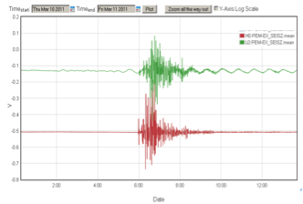
March 11, 2011: Japan magnitude 9.0 earthquake as seen on seismometers at LIGO Hanford Observatory (HO) and LIGO Livingston Observatory.

Closure
Have students take notes in their science notebooks summarizing what they have learned about variables affecting seismograms of earthquake activity.

Sidebar
Geologists study the interior of the earth using seismic waves. Go to the following web site to see a visualization of P and S waves moving through the interior of the earth. S-waves can only travel through solids, so geologists can discern which parts of the interior are not solid.
http://www.classzone.com/books/earth_science/terc/content/visualizations/es1009/es1009page01.cfm?chapter_no=visualization

5
Bridging Activity to LIGO e-Lab

Big Idea
The most commonly used data in the LIGO e-Lab are minute trends. These are one-minute averages of the power of ground vibrations in various frequency bands. The minute trend plots only make excursions in the positive vertical direction. There is no oscillation of the trace above and below a horizontal axis like those seen on a typical seismogram.

Learning Objectives
Students will be able to:
- Compare and contrast seismograms from LIGO with seismograms from other kinds of seismographs—x and y-axes, units.
- List ways, and reasons why, some LIGO data are more difficult to interpret.

Time: One 45-minute session
5 minutes introduction
35 minutes writing in journals and discussion
5 minutes for closure

Resource
The plots of LIGO’s frequency-filtered seismic data don’t look like regular seismograms. Seismic events show up as peaks on these graphs, not as up-and-down oscillations. This important difference occurs because the raw data are squared as part of the frequency filtering process and the negative portions of the plots are lost. All of the data values are positive instead of both positive and negative. The higher the peak on a filtered plot, the more energy is present in the ground vibrations. LIGO’s filtered plots provide one data point per minute.
Earthquakes that are close to LIGO show the opposite trend. Small nearby quakes transmit seismic waves that are at the higher end of LIGO’s frequency filters. The earthquake waves that are visible after hour 4 on the plot below came from an earthquake that occurred just a few miles from LIGO Hanford with a magnitude of 3.3. Notice that it only appears in the 3-10 Hertz band in LIGO’s filtered data.

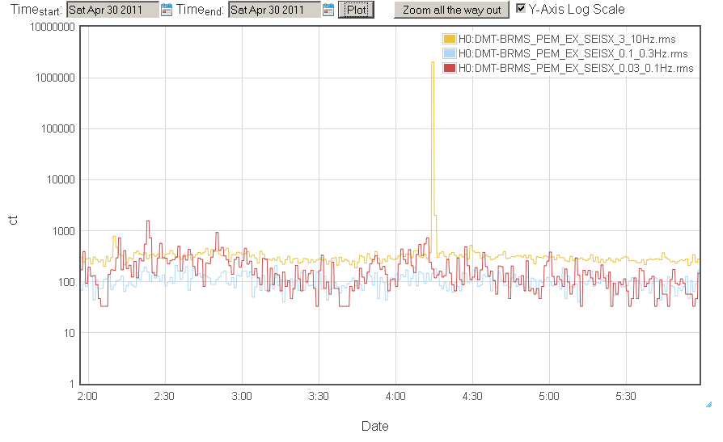

Action
Display each seismogram to the class and have a discussion. Tell students you are going to explain the first seismogram, then you will ask them to write an explanation for each of the following in their notebooks, then there will be a whole-class discussion.

Figure 1: March 11, 2011 Japan magnitude 9.0 earthquake as seen on a seismometer at LIGO Hanford Observatory
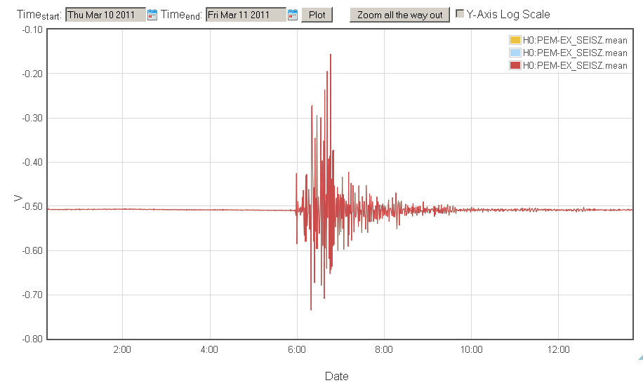

Tell students the x axis is time in a 24-hour clock and the y axis is frequency in waves per second (Hertz). Ask them to compare this seismogram with the ones they have studied in the unit so far.

Figure 2: Seismogram from both LIGO at Hanford and at Livingston observatories
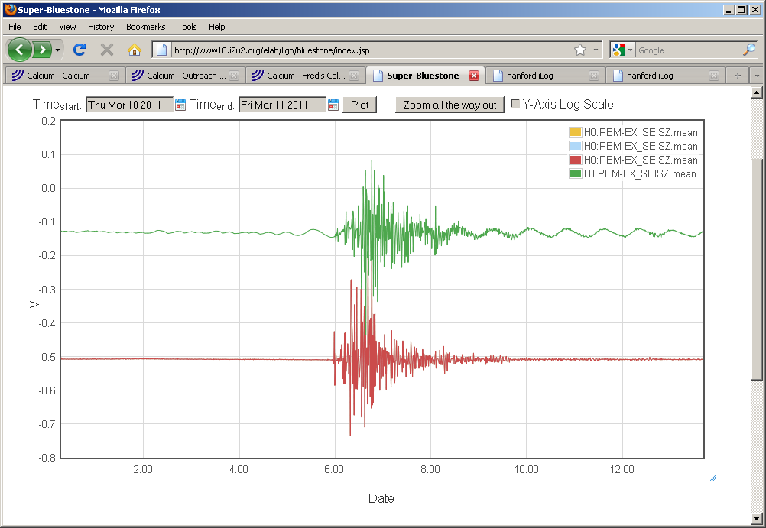

Ask students what they think may have generated the seismogram and provide evidence to support their claim.

Figure 3: The same event as Figure 2
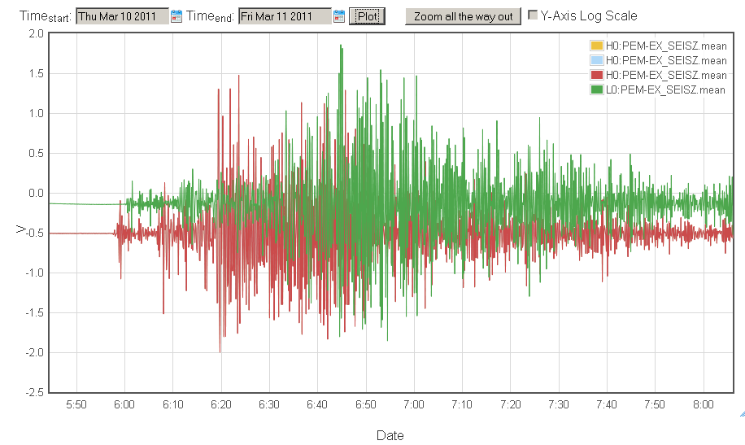

Ask students what is different about this seismogram. Why would you choose to change the scale of a seismogram? What is different about the arrival times of the waves?

Figure 4: Mystery Earthquake Event
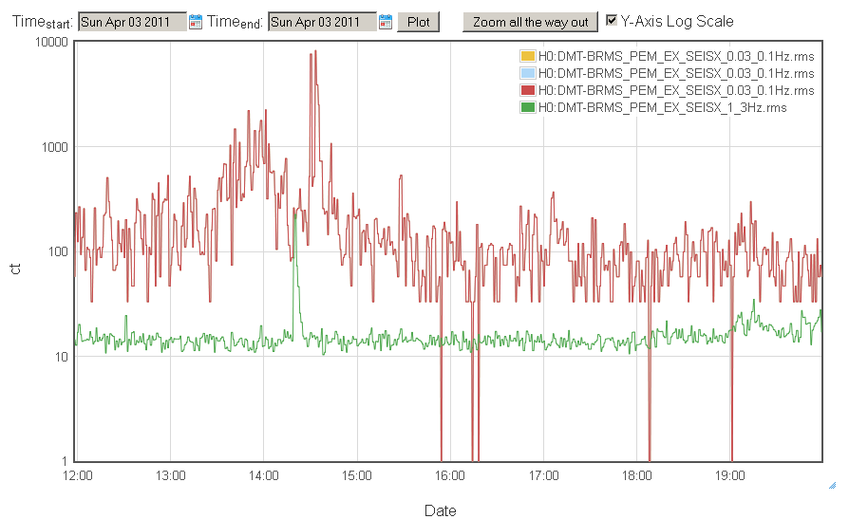

There is an earthquake in here somewhere. Can you find it? [at 14:30] Why might the seismograms you will be seeing in the LIGO e-lab be difficult to interpret?

Closure
Ask students to draw the last graph in less detail as a record of the kinds of seismograms they will see in the e-lab; ask them to be sure to label the axes.

Sidebar
Video – Einstein’s Messengers — http://www.ligo.caltech.edu describes the LIGO mission and describes gravitational waves. Have students watch the video and reinforce the idea of relating seismographic data to waves in general including gravitational waves.

5
LIGO PROJECT

Time: Six 45-minute sessions

Learning Objectives
Content and Investigation Objectives:
- Define and describe frequency in the context of wave behavior.
- Describe causes effecting the environmental changes being measured by LIGO's environmental sensing data in your study.
- Explain how LIGO's measurements of seismic waves contributes to the project's effort to detect gravitational waves.
- Design an investigation that asks a testable hypothesis, can be answered from seismic data and provides an explanation of what you learn about seismic data.
Process:
  - Explain the data collection process.
  - Collect, organize and analyze data to obtain meaningful findings.
  - Use the data to provide evidence to support their claims.
Computing:
- Explain why they used specific computing resources in their analysis.
Literacy:
- Demonstrate an ability to express meaning in writing (such as in science notebooks, reports) and come to agreement about meaning with others (such as peer review, discussion).

Resources
www18.i2u2.org/elab/ligo/home
The project uses seismic data, which are the “noise” in the LIGO experiment to detect gravitational waves. Since the observatory collects data from several sources, students can use the data they have analyzed in this unit to explore earthquakes, other mass movement and smaller scale events. A Project Map, on the initial student page, shows how students can progress through the e-lab.
The LIGO e-lab includes milestones—many of the initial milestones have been addressed in this unit—then students use LIGO data to create projects that they complete in groups. The project culminates in students creating a poster and presenting their data to the class. The posters focus on students making a claim based on the data then providing evidence to support their claim.

Appendix A: Vernier Probe Seismograph

Connect at least one, better two and ideally three Vernier or PASCO motion sensors to laptops and appropriate software (LabPro for Vernier, etc.) Point them along X, Y and Z axes at a student standing 3 to 6 feet away on a marked spot on the floor. The Z axis (looking from the top down) is the trickiest part of this exercise, and can be omitted or cleverly (but safely) engineered. With all motion sensors engaged, a student can jump front to back, side to side, up and down, staying close to (on either side of, on or above) the marked spot on the floor. Experiment with a small group adjusting distances and heights for the motion sensors prior to engaging students in this exercise.
Once the bugs have been worked out, repeat the activity with a class, making sure that they get a good view without standing in the field of view of any of the motion sensors. Have some students instruct the "target" student about how to move: "three jumps up, one left, one right, repeat", for example. After each round of data collection, identify the laptops clearly as X, Y, or Z, and then bring them together side-by-side on a wide table for class inspection and oral review. Discuss the meaning of the graphical representations of the student’s motion. Stop to design the next round with student input, and repeat several times. After several rounds of observation and discussion, discuss the ways in which these motion sensors are like seismometers, and in what ways they are not.
OPTION 1: Add a video camera to record the student’s motion for the very same duration as the motion sensors are engaged, and add video playback alongside the graphs of student motion.
OPTION 2: After graphing a student’s motion, create a small shake table using 4’x4’x1/4” plywood with a cubic object (as shoebox will do) attached to the table to reflect sound and light. Shake the table (wearing work gloves for safety) out of the field of view of the motion sensors and video, and record the movement of the block during the shaking. Review as before.
OPTION 3: Create motion maps using this set-up after working out the bugs but in advance of student use. Print them up, distribute to students after and ask students to explain in writing the motion they describe as a deployment exercise after their hands-on experience and oral review.

In this unit we use these terms, but Internet resources may use the terminology of seismometer/seismograph/seismogram in different ways.

