Separating Cosmic Ray Counters
(or: Where have all the Showers gone?)
Teacher Notes

Description
This investigation can be done with a cosmic ray detector of almost any sort in which a count of events per unit time can be made. The scientific purpose is to investigate the muon rate as a function of distance of separation between counters. The separation between two counters of a cosmic ray detector can be seen in this diagram:
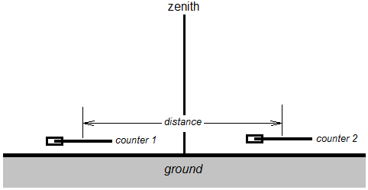
If the detector to which the counters feed pulses is set to 2-fold coincidence, 2 different muons will trigger a “hit” in the detector when one passes through counter 1 and the other through counter 2 within a defined time gate. This most likely happens as the result of a cosmic ray air shower. The question for the students is: When the distance between counters is changed, how does this affect the rate of such coincidences?

Standards
NGSS practices:
2. Developing and using models
3. Planning and carrying out investigations
4. Analyzing and interpreting data
5. Using mathematics and analytical thinking
8. Obtaining, evaluating and communicating information

Enduring Understanding
Physicists can measure cosmic rays – a phenomenon of unknown astrophysical origin – and investigate meaningful questions with can be answered through measurement.

Learning Objectives
As a result of this investigation, students will be able to:
- Take data on cosmic rays from a detector.
- Create a scatter plot and interpret the result.
- Evaluate the meaning of a plot based on a physical interpretation and understanding uncertainty.

Prior Knowledge
Students should be able to create graphs from data. It is helpful but not strictly necessary if they have a background in basic trigonometry.

Materials
Cosmic ray detector
Meter stick
Timer, if not provided on cosmic ray detector

Background Material
If students are using a QuarkNet cosmic ray detector, the teacher should have the familiarity found in the Users Manual at http://www.i2u2.org/cosmic/library/upload/b/ba/6000CRMDUserManual.pdf or http://quarknet.fnal.gov/toolkits/ati/det-user.pdf. If using a different detector, the teacher needs analogous familiarity.

Resources
Resources may be found in the Resources page of the QuarkNet Cosmic Ray e-Lab at https://www.i2u2.org/elab/cosmic/library/resources.jsp.

Teachers are encouraged to peruse “Extensive Air Showers and Ultra High-Energy
Cosmic Rays: A Historical Review” by Karl-Heinz Kampert and Alan A. Watson at http://arxiv.org/pdf/1207.4827v1.pdf. Please pay special attention to the plot on page 6.

Implementation
Use a cosmic ray detector with 2 counters in 2-fold coincidence. Students should first practice taking one-minute counts with the detector facing straight up at the zenith and the counters stacked. They will find the number of counts varies with each reading. They should plan the number of trials per angle in their experiment and from how many and which angles they should take data based on time avaialable, understaning of uncertainty, and physical limitations. They should then separate the counters to different distances and record the results in a table showing distance and rate.

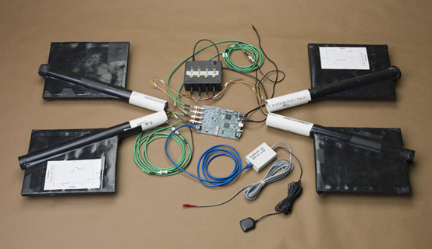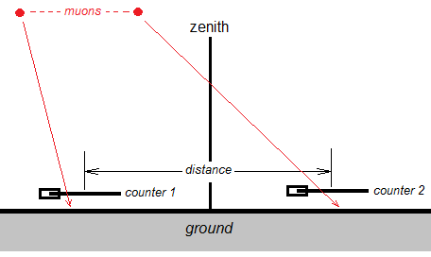
QuarkNet cosmic ray detector. Cosmic ray muons in coincidence.

It is important for students to:
- Look for anamolies in the results that might relate to the physical situation. For example, are there any nearby structures which might attenuate cosmic rays?
- Make a claim about the cosmic rays based on the data and what they already know. For example, do the results track with what they might expect based on how the frequency of air showers might vary with energy, size, or particle density? Of where cosmic rays might come from? The claim can be tentative, that is, requiring further testing beyond this experiment; students should specify this in their report.
- Take into account and discuss uncertainty in measurements.

Optional: Students can and are encouraged to make a poster in the Cosmic Ray e-Lab at http://www.i2u2.org/elab/cosmic.

Assessment
Assessment in the first instance is based on claims, evidence, and reasoning. Students have a report to fill out in which they assess based on evidence and reasoning whether the claims made were accurate and how useful the results are.

